1.25G SFP Transceiver Duplex LC 20Km
HD-S3112-20LCD

Features
  - Hot-pluggable SFP footprint
  - Duplex LC fiber connector
  - Transmission distance up to 20Km on 9/125µm SMF
  - Built-in DDMI functions
  - Comply with SFP MSA .
  - Single +3.3V power supply
  - RoHS6 compliant (lead free)
  - Operating case temperature:
Commercial : 0 to +70°C
Industrial : -40 to +85°C
  - Comply with Ethernet Switches from a lot of widely used brands .

Applications
  - Gigabit Ethernet
  - 1X Fiber Channel
  - Switch to Switch interface
  - Router/Server interface
  - Other optical transmission systems

Optical Parameters
Parameter | Symbol | Min. | Typical | Max. |  | Unit |  | Note
Transmitter Section:
Centre Wavelength | λc | 1260 | 1310 | 1360 | nm
Spectral Width (RMS) | σ |  |  | 3 | nm
Average Optical Power | Pavg | -9 |  | -3 | dBm |  | 1
Laser Off Power | Poff | - | - | -45 | dBm
Extinction Ratio | ER | 9 | - | - | dB
Relative Intensity Noise | Rin | - | - | -128 | dB/Hz |  | 12dB reflection
Transmitter jitter | UIp-p |  | - | 0.1 |  |  | 3
Optical Return Loss Tolerance |  | - | - | 12 | dB
Output Optical Eye | Compliant with IEEE802.3 z |  |  |  |  |  | 4
Receiver Section:
Receiver Center Wavelength | λr | 1260 |  | 1620 | nm
Receiver Sensitivity in Average Power | Sen | -23 |  | -3 | dBm |  | 5
Los Assert | LosA | -35 | - | - | dBm
Los Dessert | LosD | - | - | -24 | dBm
Los Hysteresis | LosH | 0.5 | - | - | dB
Overload | Pin | - | - | -3 | dBm |  | 5
Receiver Reflectance |  | - | - | -12 | dB
Receiver power (damage) |  | - | - | 0 | dBm

Notes:
1. The optical power is launched into 9/125µm SMF.
2. Unfiltered, measured with a PRBS 2²³-1 test pattern @1.25Gbps
3. Meet the specified maximum output jitter requirements if the specified maximum input jitter is present.
4. Measured with a PRBS 2²³-1 test pattern @1.25Gbps.
5. Measured with a PRBS 2²³ -1 test pattern @1.25Gbps, worst-case extinction ratio, BER ≤1×10-10

Pin Definitions
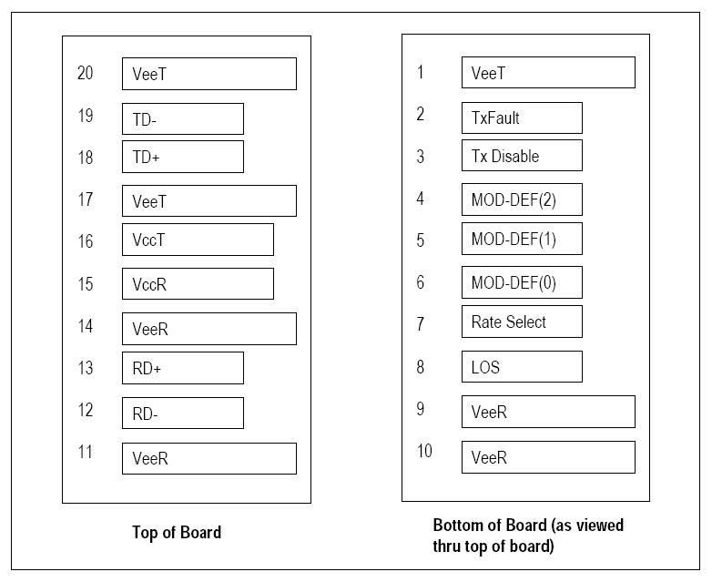

Pin | Signal Name | Description | Plug Seq | Notes
1 | VeeT | Transmitter Ground | 1
2 | TX FAULT | Transmitter Fault Indication | 3 | Note 1
3 | TX Disale | Transmitter Disable | 3 | Note 2
4 | MOD_DEF(2) | $I^{2}C$Serial Data Signal SDA | 3 | Note 3
5 | MOD_DEF(1) | $I^{2}C$Serial Clock Signal SCL | 3 | Note 3
6 | MOD_DEF(0) | Grounded in Module | 3 | Note 3
7 | Rate Select | Not Connected | 3
8 | LOS | Receiver Loss of Signal Indicator (Active high, open-drain) | 3 | Note 4
9 | VeeR | Receiver Ground | 1
10 | VeeR | Receiver Ground | 1
11 | VeeR | Receiver Ground | 1
12 | RD- | Inv. Received Data Out | 3 | Note 5
13 | RD+ | Received Data Out | 3 | Note 5
14 | VeeR | Receiver Ground | 1
15 | VccR | Receiver Power Supply | 2
16 | VccT | Transmitter Power Supply | 2
17 | VeeT | Transmitter Ground | 1
18 | TD+ | Transmit Data In | 3 | Note 6
19 | TD- | Inv. Transmit Data In | 3 | Note 6
20 | VeeT | Transmitter Ground | 1 | Note 2

Ordering information
Part Number | Product Description
HD-S3112-20LCD | 1310nm, 1.25Gbps, 20KM, Duplex LC SFP Transceiver, 0ºC ~ +70ºC , With DDM.
HD-S3112-20LCD-I | 1310nm, 1.25Gbps, 20KM, Duplex LC SFP Transceiver ,-40ºC ~ +85ºC, With DDM.

