HD-SFP+/10G-ZR

10.3Gbps SFP+ Transceiver, Single Mode, 80km Reach

Features
✓ Hot-pluggable SFP footprint
✓ Duplex LC fiber connector
Cooled EML transmitter and APD receiver
✓ Transmission distance up to 80Km on 9/125µm SMF
✓ Built-in DDMI functions
✓ Comply with SFP MSA .
✓ Single +3.3V power supply
✓ RoHS6 compliant (lead free)
✓ Operating case temperature:
Commercial : 0 to +70°C
Industrial : -40 to +85°C
✓ Comply with Ethernet Switches from a lot of widely used brands .

Applications
✓ 10GBASE Ethernet
✓ SONET OC-192 SDH STM-64
✓ Switch to Switch interface
✓ Router/Server interface
✓ Other optical transmission systems
Optical Characteristics
Parameter |  | Symbol |  | Min | Typical | Max | Unit | Notes
Transmitter
Centre Wavelength |  |  | λc | 1530 | 1550 | 1565 | nm
Spectral Width（-20dB） |  |  | Δλ |  |  | 1 | nm
Side-Mode Suppression Ratio |  |  | SMSR | 30 | - |  | dB
Average Output Power |  |  | P_{out} | 0 |  | +4 | dBm | 1
Extinction Ratio |  |  | ER | 6.0 |  |  | dB
Data Input Swing Differential |  |  | V_{IN} | 180 |  | 850 | mV | 2
Input Differential Impedance |  |  | Z_{IN} | 90 | 100 | 110 | Ω
TX Disable | Disable |  |  | 2.0 |  | Vcc | V
TX Disable | Enable |  |  | 0 |  | 0.8 | V
TX Fault | Fault |  |  | 2.0 |  | Vcc | V
TX Fault | Normal |  |  | 0 |  | 0.8 | V
Receiver
Centre Wavelength |  |  | λc | 1260 |  | 1600 | nm
Receiver Sensitivity |  |  |  |  |  | -23 | dBm | 3
Receiver Overload |  |  |  | -7 |  |  | dBm | 3
LOS De-Assert |  |  | LOS_{D} |  |  | -24 | dBm
LOS Assert |  |  | LOS_{A} | -35 |  |  | dBm
LOS Hysteresis |  |  |  | 0.5 |  | 4 | dB
Data Output Swing Differential |  |  | V_{out} | 300 |  | 900 | mV | 4
LOS |  |  | High | 2.0 |  | Vcc | V
 |  |  | Low |  |  | 0.8 | V
Notes:
1. The optical power is launched into SMF.
2. PECL input, internally AC-coupled and terminated.
3. Measured with a PRBS 2³¹-1 test pattern @10312Mbps, BER ≤1×10⁻¹².
4. Internally AC-coupled.

Pin Descriptions

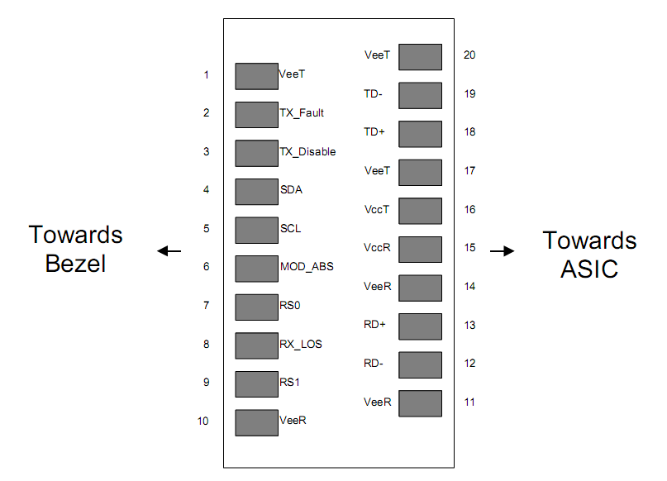

Pin | Signal Name | Description | Plug Seq. | Notes
1 | V_{EET} | Transmitter Ground | 1
2 | TX FAULT | Transmitter Fault Indication | 3 | Note 1
3 | TX DISABLE | Transmitter Disable | 3 | Note 2
4 | SDA | SDA Serial Data Signal | 3
5 | SCL | SCL Serial Clock Signal | 3
6 | MOD_ABS | Module Absent. Grounded within the module | 3
7 | RS0 | Not Connected | 3
8 | LOS | Loss of Signal | 3 | Note 3
9 | RS1 | Not Connected | 3
10 | V_{EER} | Receiver ground | 1
11 | V_{EER} | Receiver ground | 1
12 | RD- | Inv. Received Data Out | 3 | Note 4
13 | RD+ | Received Data Out | 3 | Note 4
14 | V_{EER} | Receiver ground | 1
15 | V_{CCR} | Receiver Power Supply | 2
16 | V_{CCT} | Transmitter Power Supply | 2
17 | V_{EET} | Transmitter Ground | 1
18 | TD+ | Transmit Data In | 3 | Note 5
19 | TD- | Inv. Transmit Data In | 3 | Note 5
20 | V_{EET} | Transmitter Ground | 1
Notes:
Plug Seq.: Pin engagement sequence during hot plugging.
1) TX Fault is an open collector output, which should be pulled up with a 4.7k~10kΩ resistor on the host board to a voltage between 2.0V and Vcc+0.3V. Logic 0 indicates normal operation; Logic 1 indicates a laser fault of some kind. In the low state, the output will be pulled to less than 0.8V.
2) Laser output disabled on TDIS >2.0V or open, enabled on TDIS <0.8V.
3) LOS is open collector output. Should be pulled up with 4.7k~10kΩ on host board to a voltage between 2.0V and 3.6V. Logic 0 indicates normal operation; logic 1 indicates loss of signal.
4) RD-/+: These are the differential receiver outputs. They are internally AC-coupled 100 differential lines which should be terminated with 100Ω (differential) at the user SERDES.
5) TD-/+: These are the differential transmitter inputs. They are internally AC-coupled, differential lines with 100Ω differential termination inside the module.

Ordering information
Part Number | Product Description
HD-SFP+/10G-ZR | 1550nm, 10.3Gbps, LC, 80km, 0°C~+70°C, with DDM
HD-SFP+/10G-ZR-I | 1550nm, 10.3Gbps, LC, 80km, -40°C~+85°C, with DDM

